Date:10/10/2026
CO1-Assessment Tool-1
APPLICATION BASED QUESTIONS

Course Code : DSA0308
Course Name : Natural Language Processing

Name : G.Pallavi Reg No : 192472203

- Resume Information Extraction

Aim: To extract candidate details from resumes and shortlist candidates with at least 2 years of experience and Python skill.

Problem Statement
A recruitment company receives many resumes in text format. The system must extract the candidate's name, email, mobile number, technical skills, and experience. Candidates with at least 2 years of experience and Python skill must be shortlisted.

Algorithm
- Start the program and store resume details in a string.
- Use re.search() to extract the name, email, mobile number, and experience.
- Use re.findall() to identify technical skills.
- Convert experience into an integer.
- Check whether experience is at least 2 years and Python is present.
- Display the candidate's profile and eligibility status.
- Stop the program.
Code :
import re

s = """Name: Pallavi
Email: p@gmail.com
Mobile: 9876543210
Skills: Python, Java, SQL, NLP
Experience: 3 years"""

print("Name:", re.search(r"Name: (.*)", s).group(1))
print("Email:", re.search(r"\S+@\S+\.\S+", s).group())
print("Mobile:", re.search(r"\d{10}", s).group())
print("Skills:", re.findall(r"Python|Java|SQL|NLP", s))

y = int(re.search(r"Experience: (\d+)", s).group(1))
print("Experience:", y, "years")
print("Eligible" if y >= 2 and "Python" in s else "Not Eligible")

Output :
Name: Pallavi
Email: p@gmail.com
Mobile: 9876543210
Skills: ['Python', 'Java', 'SQL', 'NLP']
Experience: 3 years
Eligible

Screenshort of output :

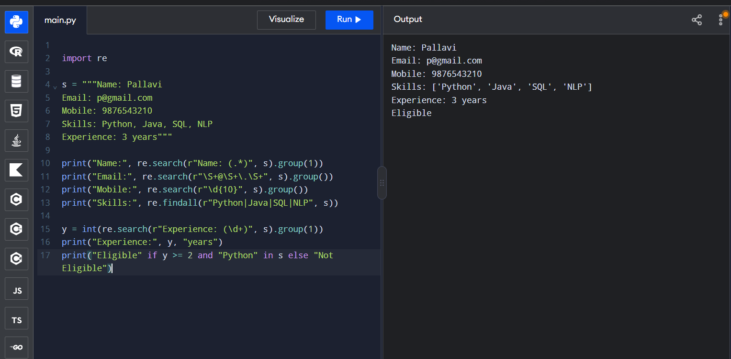
Result: Resume details were extracted and eligibility was checked.

2. Product Search System
Aim: To search products using exact, prefix, suffix, partial, and case-insensitive matching and count the matching products
Problem Statement
An e-commerce company wants to improve product searching. The system must search a list of products using different keyword-matching techniques and display all matching product names along with the total number of matches.
Algorithm
- Start the program and create a list of product names.
- Define a search function that accepts a keyword and search mode.
- Create a suitable regular expression for the selected search mode.
- Use re.search() with re.I for case-insensitive matching.
- Store all matching products in a list.
- Display the matching product names and total count.
- Repeat the search for different modes and stop the program.
Code :

import re
p = ["Apple iPhone", "Apple Watch", "Apple Laptop"]
k = input("Keyword: ")
r = [x for x in p if re.search(k, x, re.I)]
print("Matching Products:", r)
print("Total Products:", len(r))

Output :
Keyword: apple iphone
Matching Products: ['Apple iPhone']
Total Products: 1

Screenshort of output :
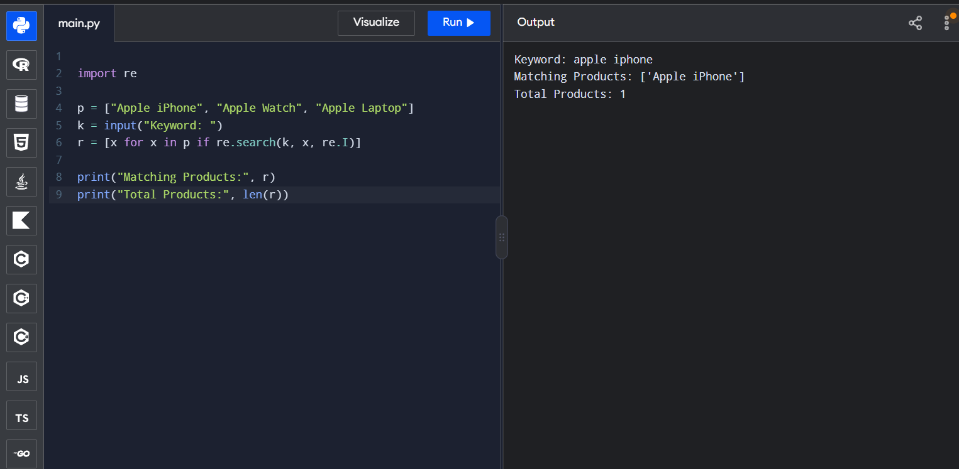

Result: Matching products and their total count are displayed.

3. Regular Expressions – University Registration System
Aim
To develop a Python-based university registration validation system using Regular Expressions to verify student details and generate a final registration status report.
Problem Statement
A university registration portal needs to validate student register numbers, institutional email addresses, course codes, semester information, and mobile numbers before enrollment. The system must display validation messages for each field and confirm whether registration is successful.
Algorithm
- Start the program and read the student's registration details.
- Define Regular Expression patterns for each field.
- Validate each input using re.fullmatch().
- Display a valid or invalid message for each field.
- Set the registration status to failed if any field is invalid.
- Display the final registration status.
- Stop the program.

Python Program
import re
reg = input("Register Number: ")
email = input("Email: ")
mobile = input("Mobile: ")
a = bool(re.fullmatch(r"\d{12}", reg))
b = bool(re.fullmatch(r"[\w.-]+@[\w.-]+\.edu\.in", email))
c = bool(re.fullmatch(r"[6-9]\d{9}", mobile))
print("Register Number:", "Valid" if a else "Invalid")
print("Email:", "Valid" if b else "Invalid")
print("Mobile:", "Valid" if c else "Invalid")
print("Registration Successful" if a and b and c else "Registration Failed")
Output :
Register Number: 192472203
Email: pallavi132333@gmail.com
Mobile: 1234567890
Register Number: Invalid
Email: Invalid
Mobile: Invalid
Registration Failed

Screenshort of output :
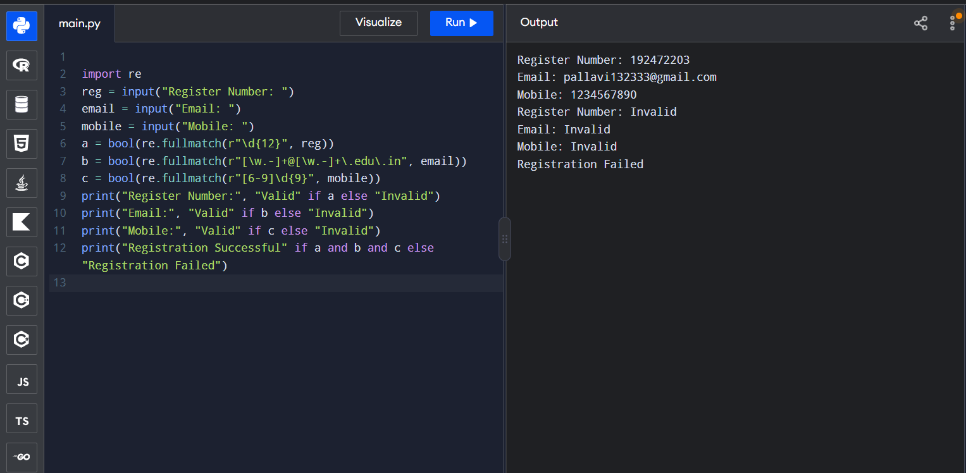

Result: Student information was validated and the final registration status was generated.

